**STUDENT EXAMINATION PORTAL**

## Submitted by

**Name of the Student: Semanti Datta**

**Enrolment Number:** 12022002002193

**Section:** A

**Class Roll Number:** 90

**Stream:** CSE CORE

**Subject:** Programming for Problem Solving with Python

**Subject Code:** IVC101

**Department:** Basic Science and Humanities

Under the supervision of

Dr. Indrajit De

**Academic Year: 2022-26**

PROJECT REPORT SUBMITTED IN PARTIAL FULFILLMENT OF THE REQUIREMENTS FOR THE FIRST SEMESTER



**DEPARTMENT OF BASIC SCIENCE AND HUMANITITES**

**INSTITUTE OF ENGINEERING AND MANAGEMENT, KOLKATA**



## CERTIFICATE OF RECOMMENDATION

We hereby recommend that the project prepared under our supervision by **Semanti Datta,** entitled STUDENT EXAMINATION PORTAL be accepted in partial fulfillment of the requirements for the degree of partial fulfillment of the first semester.

Head of the Department Project Supervisor

Basic Sciences and Humanities IEM, Kolkata

# Introduction

In this project we create various modules using Python to create databases (as CSV files) in which we can store information about students, courses , batches, departments and marks obtained by students in a particular examination. We can also display pie charts, histograms etc. on the basis of the data stored in the csv files

## Objective

To create various Python modules for a **Student Examination Portal.** Create a student’s database of his/her batch, course, department, examination details and generate a report card.

## Organization of the Project

The project is organized into 6 different modules namely studentportal.py, studentpart.py, onlycourse.py, batchonly.py, deptonly.py, and examonly.py. The first module holds the control of the entire portal. It asks us which section we want to open:- 1.Student Details 2.Course Details 3.Batch Details 4.Department Details 5.Examination Details 6.Exit If we go for the first option we will get into the studentpart.py module and perform various operations on the Student.csv file which will result in changes in the Batch.csv, Result.txt and Course.csv files. If we go for the second option we will get into the onlycourse.py module and perform various operations on the Course.csv file which will result in changes in the Batch.csv, Department.csv and Student.csv files. If we go for the third option we will get into the batchonly.py module and perform various operations on the Batch.csv file which will result in changes in the Department.csv, Student.csv and Course.csv files. If we go for the fourth option we will get into the deptonly.py module and perform various operations on the Department.csv file which will result in changes in the Batch.csv and Course.csv files. If we go for the fifth option we will get into the examonly.py module and display various stats. If you go for the final option we exit the program control.

# Database Descriptions

Student.csv stores the student id, name roll no. and batch id of various students

Course.csv stores the course id, course name, and a dictionaries with student ids as keys and their marks in the particular course as values for various courses.

Batch.csv stores the Batch id, Batch name, Department name (id), list of courses in the batch and list of students in the batch for various batches.

Department.csv stores the department name, department id and the list of batches in the department for various departments

## Database Samples

Provides samples of the database that are created or used.



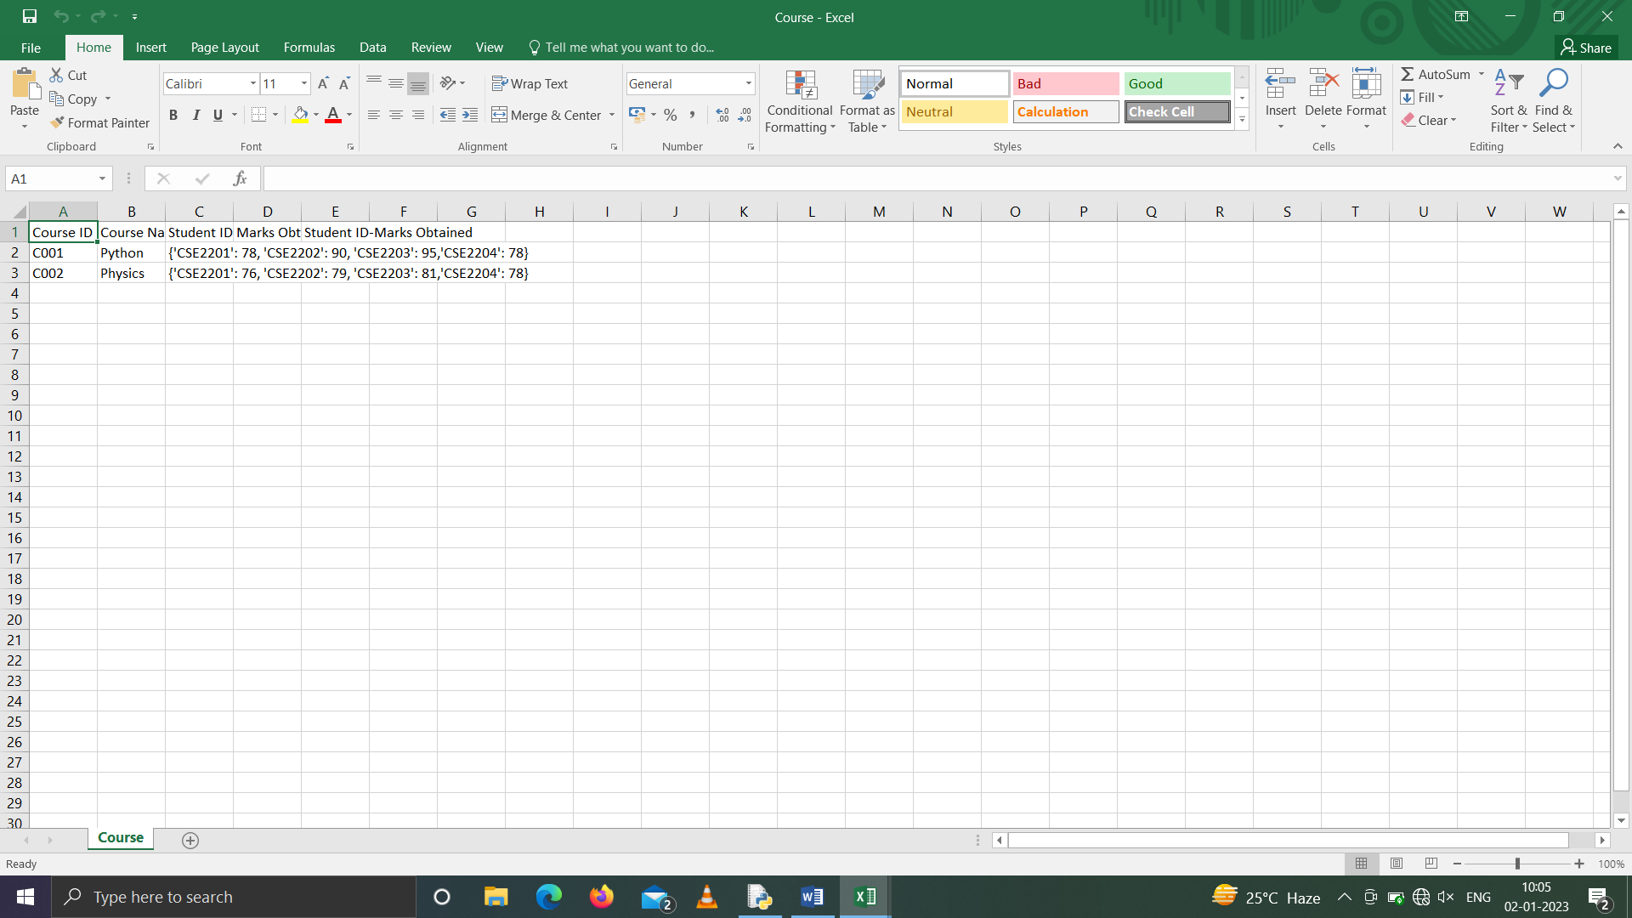





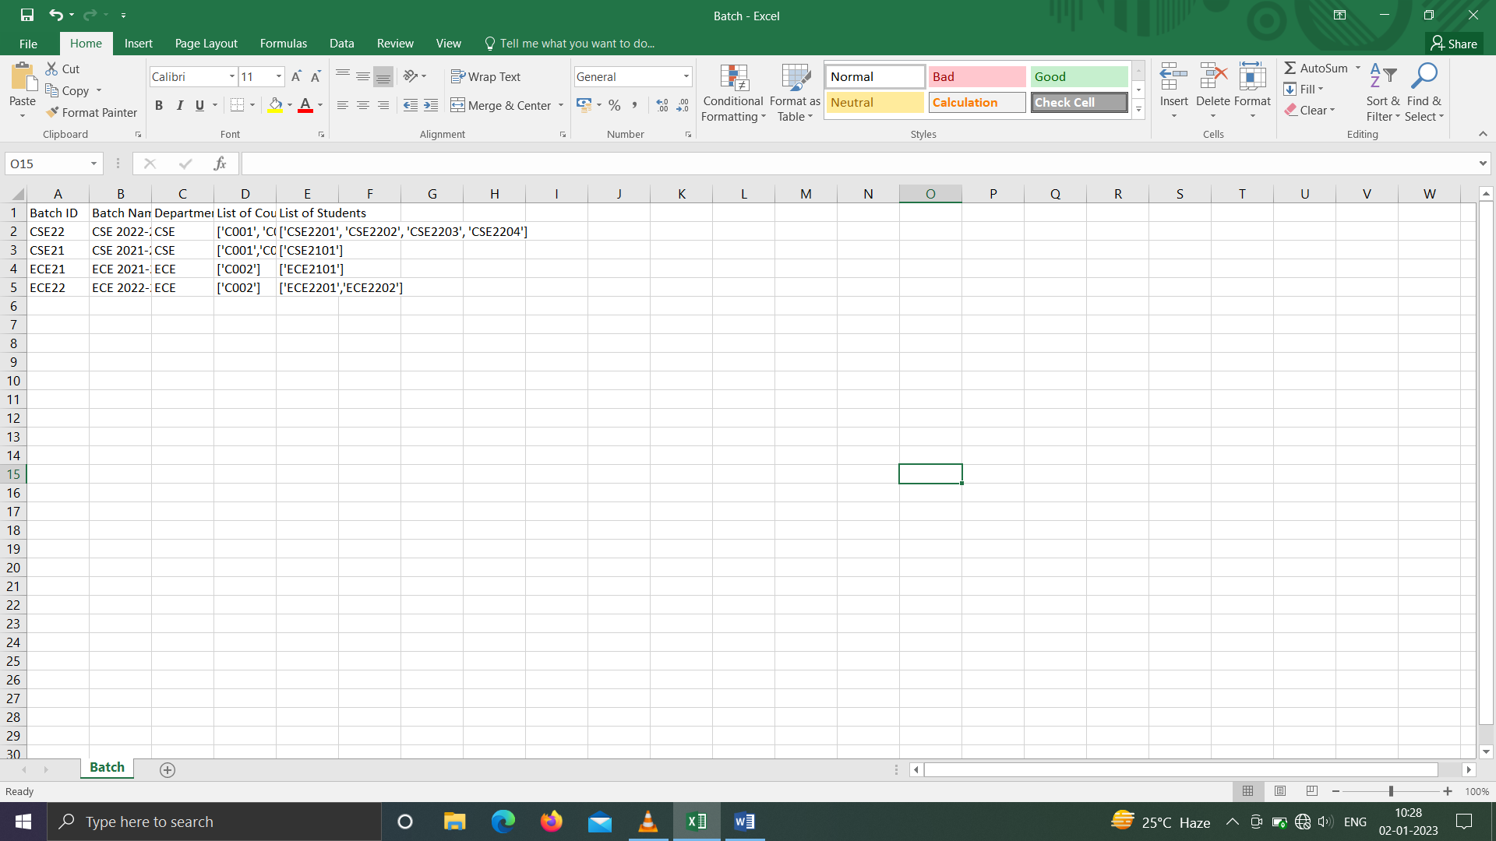

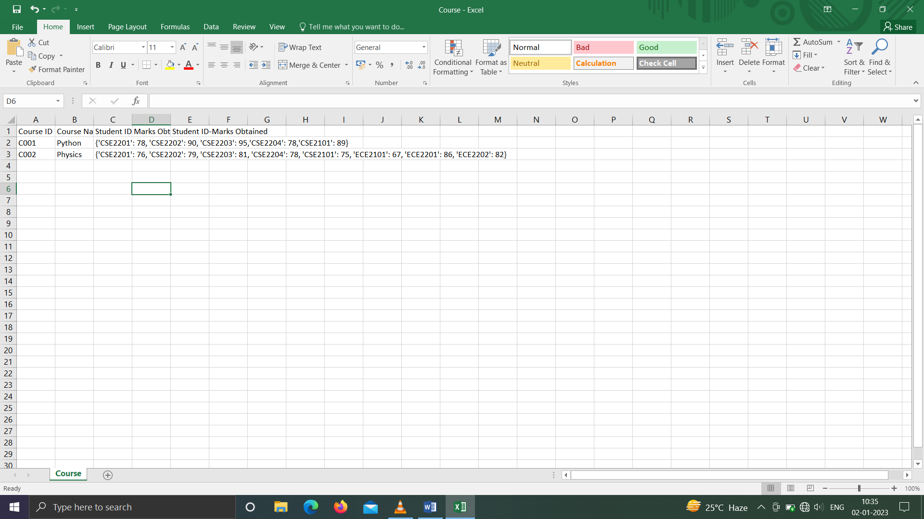



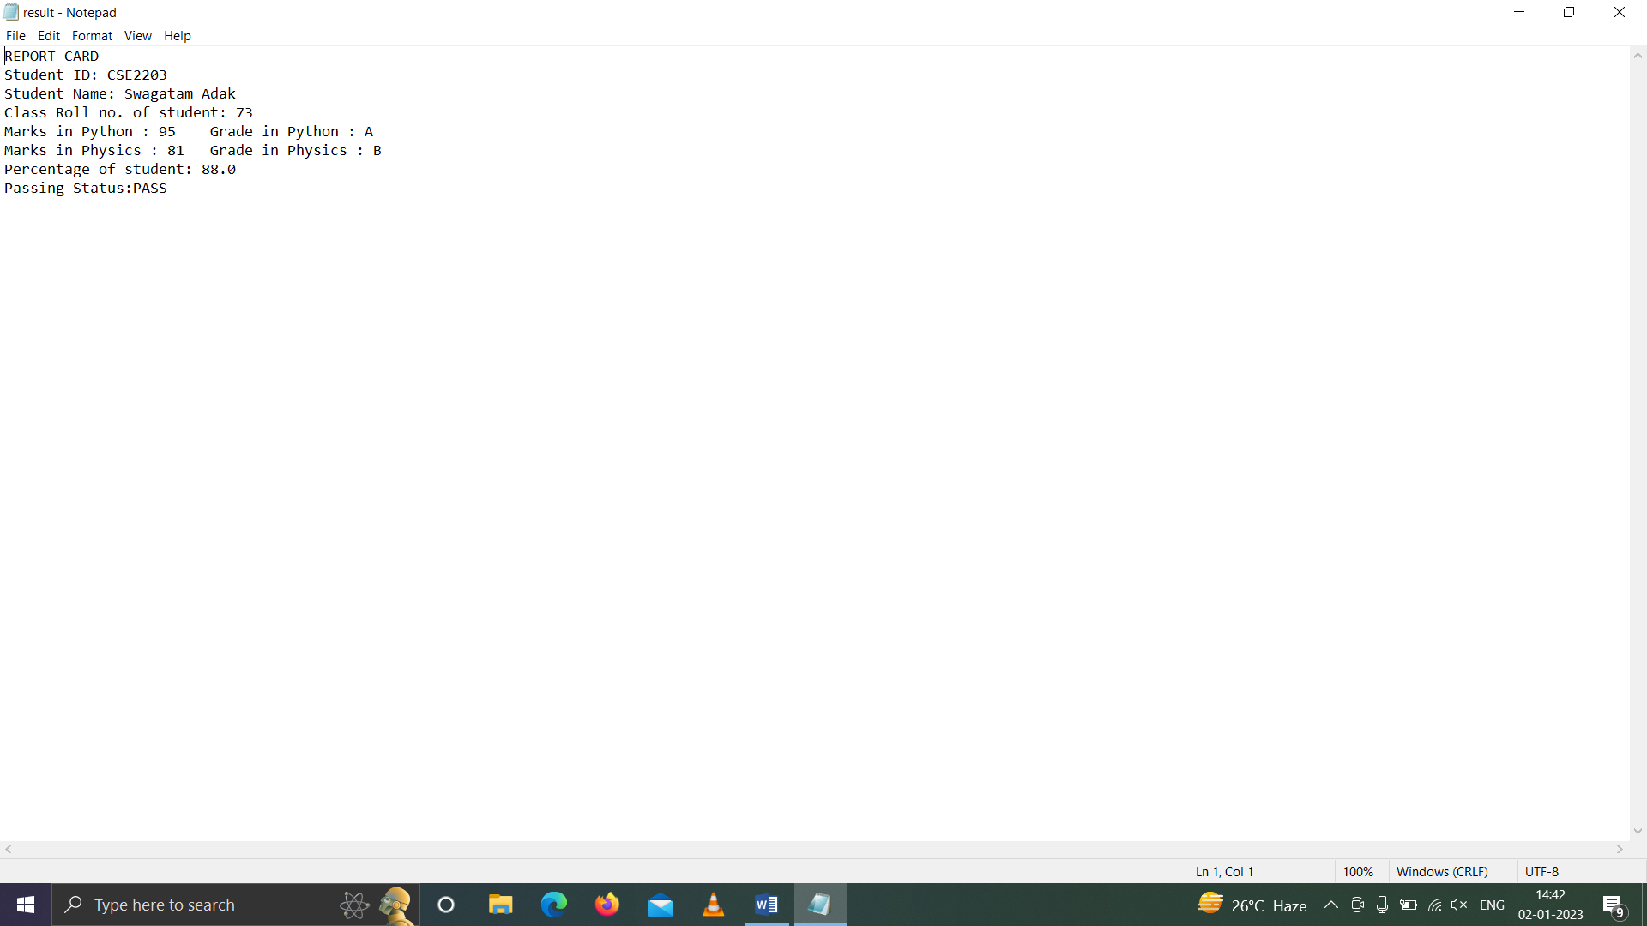

# Data Flow and E-R Diagrams

Demonstrate the dependency of all the python modules written using data flow diagrams



Create Instance

Fetch Data

Module 1 Module 2 Module 3

Update Value

Calculate Value

View Data

Module 4 Module 5

# Programs

Provide the python programs of the various modules.

1. rootDir/studentportal.py

# Student Examination Portal

import csv

import os

import deptonly

import examonly

import studentpart

import batchonly

import onlycourse

while True:

print('1.Student Details')

print('2.Course Details')

print('3.Batch Details')

print('4.Department Details')

print('5.Examination Details')

print('6.END')

ch=int(input('Enter your choice:'))

if ch==1:

studentpart.studentpart()

elif ch==2:

onlycourse.coursepart()

elif ch==3:

batchonly.batchonly()

elif ch==4:

deptonly.deptonly()

elif ch==5:

examonly.exam()

elif ch==6:

break

else:

print('INVALID INPUT!!')

print('Enter again')

1. rootDir/studentpart.py

import csv

import os

import pandas as pd

import json

path1='Student.csv'

if os.path.isfile(path1):

pass

else:

fob1=open('Student.csv','a',newline='')

wob1=csv.writer(fob1)

wob1.writerow(['Student ID','Name','Class Roll No.','Batch ID'])

fob1.close()

def grading(num):

var='PASS'

if num>=90:

grade='A'

elif num>=80 and num<90:

grade='B'

elif num>=70 and num<80:

grade='C'

elif num>=60 and num<70:

grade='D'

elif num>=40 and num<60:

grade='E'

elif num<40:

grade='F'

var='FAIL'

return([var,grade])

def checkincourse(stuid):

c,cnm={},''

f=open('Course.csv','r')

r=csv.reader(f)

for row in r:

if (stuid in eval(row[2])) == True:

c=eval(row[2])

cnm=row[1]

f.close()

if c!={} and cnm!='':

return([cnm,c])

else:

return(False)

def batid(bid):

l=[]

f=open('Batch.csv','r')

r=csv.reader(f)

for row in r:

l.append(row[0])

f.close()

return (bid in l)

def studentpart():

while True:

print('a.Create a new student')

print('b.Update student details')

print('c.Remove a student from the database')

print('d.Generate report card')

print('e.Exit')

ch1=input('Enter your choice:')

if ch1 in ('a','A'):

while True:

c=0

id=input('Enter Student ID:')

with open('Student.csv','r') as f:

r=csv.reader(f)

for i in r:

if i[0]==id:

c=1

if c==1:

print("This student already exists.Try again!!!")

continue

nm=input('Enter name of the Student:')

croll=input('Enter class roll number:')

B_Id=input('Enter Batch ID:')

while batid(B_Id)==False:

print("Batch doesn't exist.Try again!!!")

B_Id=input('Enter Batch ID:')

f=open('Student.csv','a',newline='')

w=csv.writer(f)

w.writerow([id,nm,croll,B_Id])

f.close()

c,l1,l2,s1,s2=0,[],[],'',''

with open('Batch.csv','r') as f:

r=csv.reader(f)

for i in r:

if B_Id==i[0]:

s1=i[3]

s1=s1[1:(len(s1)-1)]

s1=s1+','

x=''

for j in s1:

if j==',':

l1.append(x)

x=''

continue

x=x+j

s2=i[4]

s2=s2[1:(len(s2)-1)]

s2=s2+','

x=''

for j in s2:

if j==',':

l2.append(x)

x=''

continue

x=x+j

break

c=c+1

l2.append(id)

df = pd.read_csv("Batch.csv")

df.loc[c, 'List of Students'] = str(l2)

df.to_csv('Batch.csv',index=False)

for i in l1:

c,xd=0,{}

with open('Course.csv','r') as f:

r=csv.reader(f)

for j in r:

if i==j[0]:

xd=eval(j[2])

break

c=c+1

xd[id]=int(input("Enter marks of student in course"+i+":"))

df = pd.read_csv("Course.csv")

df.loc[c, 'Student ID-Marks Obtained'] = str(xd)

df.to_csv('Course.csv',index=False)

sch1=input('Enter more records?(y/n):')

if sch1 in ('n','N'):

break

elif ch1 in('b','B'):

while True:

c,x=-1,0

id=input('Enter the Student ID of the student whose details you want to update:')

while True:

c,x=-1,0

with open('Student.csv','r') as f:

r=csv.reader(f)

for i in r:

if i[0]==id:

x=1

break

c=c+1

if x==0:

print("Student ID does not exist.Try again!!!")

id=input('Enter the Student ID of the student whose details you want to update:')

else:

break

nm=input('Enter name of the Student:')

roll=input('Enter class roll number:')

df = pd.read_csv("Student.csv")

df.loc[c, 'Name'] = nm

df.loc[c, 'Class Roll No.'] = roll

df.to_csv('Student.csv',index=False)

sch2=input('Update more records?(y/n)')

if sch2 in ('n','N'):

break

elif ch1 in ('c','C'):

while True:

c,x=-1,0

id=input('Enter the Student ID of the student whose details you want to delete:')

while True:

c,x=-1,0

with open('Student.csv','r') as f:

r=csv.reader(f)

for i in r:

if i[0]==id:

x=1

break

c=c+1

if x==0:

print("Student ID does not exist.Try again!!!")

id=input('Enter the Student ID of the student whose details you want to delete:')

else:

break

df = pd.read_csv("Student.csv")

df.drop(c,axis=0,inplace=True)

sch3=input('Delete more records?(y/n)')

if sch3 in ('n','N'):

break

elif ch1 in('d','D'):

while True:

c,x,li,nm,roll=0,0,[],'',0

id=input('Enter the Student ID of the student whose report card you want to generate:')

while True:

x=0

with open('Student.csv','r') as f:

r=csv.reader(f)

for i in r:

if i[0]==id:

nm,roll,x=i[1],i[2],1

break

if x==0:

print("Student ID does not exist.Try again!!!")

id=input('Enter the Student ID of the student whose report card you want to generate:')

else:

break

c,d,Tmarks=0,{},0

with open('Course.csv','r') as f :

r=csv.reader(f)

for i in r:

if id in i[2]:

d[i[1]]=(eval(i[2]))[id]

Tmarks=Tmarks+(eval(i[2]))[id]

c=c+1

with open('Result.txt','w+') as file:

file.write("REPORT CARD\n")

file.write("Student ID: "+id+'\n')

file.write("Student Name: "+nm+'\n')

file.write("Class Roll no. of student: "+roll+'\n')

for i in d:

file.write("Marks in "+i+" : "+str(d[i])+'\t'+"Grade in "+i+" : "+str((grading(d[i]))[1])+'\n')

file.write("Percentage of student: "+str(Tmarks/c)+'\n')

file.write("Passing Status:"+str((grading(Tmarks/c))[0])+'\n')

with open('Result.txt','r') as file:

print(file.read())

sch6=input('Generate more report cards?(y/n):')

if sch6 in ('n','N'):

break

elif ch1 in('e','E'):

break

else:

print('INVALID INPUT!!')

print('Enter again')

1. rootDir/onlycourse.py

import csv

import os

import numpy as np

import matplotlib.pyplot as plt

path='Course.csv'

if os.path.isfile(path):

pass

else:

fob=open('Course.csv','a',newline='')

wob=csv.writer(fob)

wob.writerow(['Course ID','Course Name','Student ID-Marks Obtained'])

fob.close()

def check1(id):

l=[]

f=open('Course.csv','r')

r=csv.reader(f)

for row in r:

l.append(row[0])

f.close()

return (id in l)

def check2(nm):

l=[]

f=open('Course.csv','r')

r=csv.reader(f)

for row in r:

l.append(row[1])

f.close()

return (nm in l)

def check3(stuid):

c=False

f=open('Course.csv','r')

r=csv.reader(f)

for row in r:

if (stuid in eval(row[2])) == True:

c=True

f.close()

return(c)

def coursepart():

while True:

print('a.Create a new course')

print('b.View performance of all students in the course')

print('c.Show course statistics')

print('d.Exit')

ch2=input('Enter your choice:')

if ch2 in ('a','A'):

while True:

l2a2,l2a3,l2a4=[],{},[]

a2=input('Enter Course ID:')

b2=input('Enter Course Name:')

if (check1(a2)==True or check2(b2)==True):

print("Course already present, Try again!!")

continue

ask2a1=int(input('Enter the number of students in the course:'))

for i in range(0,ask2a1):

c2=input(f'Student ID of no. {i+1} :')

while True:

if c2 in l2a3:

print('This Student already exists in this course!')

print('Enter again')

c2=input('Student ID:')

else:

break

d2=int(input('Enter the Total marks:'))

l2a3[c2]=d2

l2a4.append([a2,b2,str(l2a3)])

fob2=open('Course.csv','a',newline='')

wob2=csv.writer(fob2)

wob2.writerows(l2a4)

fob2.close()

sch2=input('Enter more Courses?(y/n):')

if sch2 in ('n','N'):

break

elif ch2 in('b','B'):

while True:

d,e={},{}

c=input('Enter course ID:')

with open('Course.csv','r') as f1 , open('Student.csv','r') as f2 :

r1=csv.reader(f1)

r2=csv.reader(f2)

for i in r1:

if i[0]==c:

print("Course Name:",i[1])

d=eval(i[2])

for i in d:

e[i]=[]

for i in r2:

if i[0] in d:

e[i[0]].append(i[1])

e[i[0]].append(i[2])

if d=={} and e=={}:

print("Course not present.TRY again!!!")

continue

for i in d:

print('Student ID:',i)

print('Name:',(e[i])[0])

print('Class Roll No.',(e[i])[1])

print('Marks in ',i,':',d[i])

print('-----------------------------')

x=input("Check student details of more courses?(y/n):")

if x in ('n','N'):

break

elif ch2 in ('c','C'):

a = np.array([22, 87, 5, 43, 56,

73, 55, 54, 11,

20, 51, 5, 79, 31,

27])

fig, ax = plt.subplots(figsize =(10, 7))

ax.hist(a, bins = [0, 25, 50, 75, 100])

plt.show()

elif ch2 in('d','D'):

break

else:

print("Invalid Input.Try again!!!")

1. rootDir/batchonly.py

import csv

import os

import pandas as pd

import numpy as np

import matplotlib.pyplot as plt

path3='Batch.csv'

if os.path.isfile(path3):

pass

else:

f=open('Batch.csv','a',newline='')

w=csv.writer(f)

w.writerow(['Batch ID','Batch Name','Department Name','List of Courses','List of Students'])

f.close()

def batchid(bid):

l=[]

f=open('Batch.csv','r')

r=csv.reader(f)

for row in r:

l.append(row[0])

f.close()

return (bid in l)

def grad(num):

var='PASS'

if num>=90:

grade='A'

elif num>=80 and num<90:

grade='B'

elif num>=70 and num<80:

grade='C'

elif num>=60 and num<70:

grade='D'

elif num>=40 and num<60:

grade='E'

elif num<40:

grade='F'

var='FAIL'

return([var,grade])

def batchname(bnm):

l=[]

f=open('Batch.csv','r')

r=csv.reader(f)

for row in r:

l.append(row[1])

f.close()

return (bnm in l)

def batchonly():

while True:

print('a.Create a new batch')

print('b.View list of all students in a batch')

print('c.View list of all courses taught in the batch')

print('d.View complete performance of all students in a batch')

print('e.Pie chart of percentage of all students in a batch')

print('f.EXIT')

ch3=input('Enter your choice:')

if ch3 in ('a','A'):

while True:

l1,l2,l3=[],[],[]

bid=input('Enter Batch ID:')

while batchid(bid)==True:

print("Batch already exists.Try again!!!")

bid=input('Enter Batch ID:')

bnm=input('Enter Batch Name:')

while batchname(bnm)== True:

print("Batch already exists.Try again!!!")

bnm=input('Enter Batch Name:')

deptnm=input('Enter Department Name:')

n1=int(input('Enter the number of courses in the batch:'))

n2=int(input('Enter the number of students in the batch:'))

for i in range(n1):

cid=input(f'Enter Course ID of No.{i+1}:')

while cid in l1:

print("Course already exists.Try again!!!")

cid=input(f'Enter Course ID of No.{i+1}:')

l1.append(cid)

for i in range(n2):

stuid=input(f'Enter Student ID of No.{i+1}:')

while stuid in l2:

print("Student already exists.Try again!!!")

stuid=input(f'Enter Student ID of No.{i+1}:')

l2.append(stuid)

l3.append([bid,bnm,deptnm,str(l1),str(l2)])

f=open('Batch.csv','a',newline='')

w=csv.writer(f)

w.writerows(l3)

f.close()

sch3=input('Enter more records?(y/n):')

if sch3 in ('n','N'):

break

elif ch3 in('b','B'):

li=[]

bid=input('Enter the required batch ID:')

while batchid(bid)==False:

print("Batch doesn't exist.Try again!!!")

bid=input('Enter Batch ID:')

with open('Batch.csv','r') as f:

r=csv.reader(f)

for i in r:

if i[0]==bid:

li=i[4]

print('The students enrolled in the given batch are:')

print(li)

elif ch3 in('c','C'):

li,s1=[],''

bid=input('Enter the required batch ID:')

while batchid(bid)==False:

print("Batch doesn't exist.Try again!!!")

bid=input('Enter Batch ID:')

with open('Batch.csv','r') as f:

r=csv.reader(f)

for i in r:

if i[0]==bid:

s1=i[3]

s1=s1[1:(len(s1)-1)]

s1=s1+','

x=''

for j in s1:

if j==',':

li.append(x.strip("'"))

x=''

continue

x=x+j

print('The courses in the given batch are:')

for i in li:

print(i,end=' ')

print()

elif ch3 in('d','D'):

li,s1=[],''

bid=input('Enter the required batch ID:')

while batchid(bid)==False:

print("Batch doesn't exist.Try again!!!")

bid=input('Enter Batch ID:')

with open('Batch.csv','r') as f:

r=csv.reader(f)

for i in r:

if i[0]==bid:

s1=i[4]

s1=s1[1:(len(s1)-1)]

s1=s1+','

x=''

for j in s1:

if j==',':

li.append((x.strip()).strip("'"))

x=''

continue

x=x+j

for i in li:

print("Student ID:",i)

with open('Student.csv','r') as f:

r=csv.reader(f)

for j in r:

if i in j[0]:

print("Student Name:",j[1])

print("Class Roll No. of student:",j[2])

c,Tmarks=0,0

with open('Course.csv','r') as f:

r=csv.reader(f)

for j in r:

if i in j[2]:

print("Marks in ",j[1],":",(eval(j[2]))[i])

print("Marks in ",j[1],":",grad((eval(j[2]))[i])[1])

Tmarks=Tmarks+(eval(j[2]))[i]

c=c+1

print("Percentage of student:",Tmarks/c)

print("Passing Status:",grad(Tmarks/c)[0])

print("----------------------------------")

elif ch3 in('e','E'):

li,s1,perc,sumperc=[],'',[],0

bid=input('Enter the required batch ID:')

while batchid(bid)==False:

print("Batch doesn't exist.Try again!!!")

bid=input('Enter Batch ID:')

with open('Batch.csv','r') as f:

r=csv.reader(f)

for i in r:

if i[0]==bid:

s1=i[4]

s1=s1[1:(len(s1)-1)]

s1=s1+','

x=''

for j in s1:

if j==',':

li.append((x.strip()).strip("'"))

x=''

continue

x=x+j

for i in li:

print("Student ID:",i)

c,Tmarks=0,0

with open('Course.csv','r') as f:

r=csv.reader(f)

for j in r:

if i in j[2]:

Tmarks=Tmarks+(eval(j[2]))[i]

c=c+1

perc.append(Tmarks/c)

sumperc=sumperc+(Tmarks/c)

for i in range(0,len(li)):

perc[i]=(perc[i]/sumperc)*100

y=np.array(perc)

plt.pie(y,labels=li)

plt.show()

elif ch3 in('f','F'):

break

else:

print("Invalid Input.Try again!!!")

1. rootDir/deptonly.py

import csv

import os

import pandas as pd

import matplotlib.pyplot as plt

import numpy as np

path='Department.csv'

if os.path.isfile(path):

pass

else:

f=open('Department.csv','a',newline='')

w=csv.writer(f)

w.writerow(['Department ID','Department Name','List of batches'])

f.close()

def checkdeptid(deptid):

c=False

f=open('Department.csv','r')

r=csv.reader(f)

for row in r:

if (deptid in row[0]) == True:

c=True

break

f.close()

return c

def checkdeptnm(deptnm):

c=False

f=open('Department.csv','r')

r=csv.reader(f)

for row in r:

if (deptnm in row[1]) == True:

c=True

break

f.close()

return c

def studadd(bid):

li,s1,bmarks=[],0,''

with open('Batch.csv','r') as f:

r=csv.reader(f)

for i in r:

if i[0]==bid:

s1=i[4]

s1=s1[1:(len(s1)-1)]

s1=s1+','

x=''

for j in s1:

if j==',':

li.append((x.strip()).strip("'"))

x=''

continue

x=x+j

for i in li:

c,Tmarks=0,0

with open('Course.txt','r') as f:

r=csv.reader(f)

for j in r:

if i in j[2]:

Tmarks=Tmarks+(eval(j[2]))[i]

c=c+1

bmarks=bmarks+(Tmarks/c)

return(bmarks/len(li))

def checkbid(bid):

c=False

f=open('Department.csv','r')

r=csv.reader(f)

for row in r:

if (bid in row[2]) == True:

c=True

break

f.close()

return c

def deptonly():

while True:

print('a.Create a new Department')

print('b.View all batches in a department')

print('c.View average performance of all batches in a departmment')

print('d.Show department statistics')

print('e.EXIT')

ch4=input('Enter your choice:')

if ch4 in('a','A'):

while True:

li=[]

id=input('Enter Department ID:')

while checkdeptid(id)==True:

print('This department exists.Try again!!!')

id=input('Enter Department ID:')

nm=input('Enter Department Name:')

while checkdeptnm(nm)==True:

print('This department exists.Try again!!!')

nm=input('Enter Department Name:')

n=int(input('Enter no. of batches in this department:'))

bid=[]

for i in range(0,n):

bnm=input(f'Enter name of Batch {i+1}:')

while checkdeptnm(bnm)==True:

print('This batch already exists.Try again!!!')

bnm=input(f'Enter name of Batch {i+1}:')

bid.append(bnm)

li=[id,nm,bid]

f=open('Department.csv','a',newline='')

w=csv.writer(f)

w.writerow(li)

f.close()

sch4=input('Enter more records(y/n):')

if sch4 in('n','N'):

break

elif ch4 in('b''B'):

li=[]

id=input('Enter Department ID:')

while checkdeptid(id)==False:

print('This department does not exist.Try again!!!')

id=input('Enter Department ID:')

with open('Department.csv','r') as f:

r=csv.reader(f)

for i in r:

if id==i[0]:

li=i[2]

print('All The Batches in this Department are:')

for i in li:

print(i,end=' ')

print()

elif ch4 in('c','C'):

li=[]

id=input('Enter Department ID:')

while checkdeptid(id)==False:

print('This department does not exist.Try again!!!')

id=input('Enter Department ID:')

with open('Department.csv','r') as f:

r=csv.reader(f)

for i in r:

if id==i[0]:

li=i[2]

for i in li:

print('Average performance of batch ',i," : ",studadd(bid))

elif ch4 in('d','D'):

ypoints = np.array([3, 8, 1, 10])

plt.plot(ypoints, linestyle = 'dotted')

plt.show()

elif ch4 in('e','E'):

break

else:

print("Invalid Choice.Try again!!!")

1. rootDir/examonly.py

import csv

import os

import pandas

import numpy as np

import matplotlib.pyplot as plt

def checkcid(id):

l=[]

f=open('Course.csv','r')

r=csv.reader(f)

for row in r:

l.append(row[0])

f.close()

return (id in l)

def exam():

z={}

while True:

print('a.Enter the marks of all students for a specific examination')

print('b.View performance of all students in the above examination')

print('c.Show examination statistics')

print('d.Exit')

ch2=input('Enter your choice:')

m,cid={},''

if ch2 in ('a','A'):

cid=input('Enter Course ID:')

while checkcid(cid)==False:

print("The course is not present.Try again!!!")

cid=input('Enter Course ID:')

with open('Course.csv','r') as f:

r=csv.reader(f)

for i in r:

if i[0]==cid:

m=eval(i[2])

for i in m:

m[i]=int(input("Enter marks of student:"+i))

z=m

elif ch2 in('b','B'):

print("Performance of all students enrolled in the course for ",cid," : ")

for i in z:

print("Student ID:"+i+"\t"+"Marks:"+str(z[i]))

elif ch2 in('c','C'):

x = np.array([5,7,8,7,2,17,2,9,4,11,12,9,6])

y = np.array([99,86,87,88,81,86,73,87,94,78,77,85,86])

plt.scatter(x, y)

x = np.array([2,2,8,1,15,8,12,9,7,3,11,4,7,14,12])

y = np.array([100,90,84,85,90,99,90,95,94,91,79,77,91,80,85])

plt.scatter(x, y)

plt.show()

elif ch2 in('d','D'):

break

else:

print("Invalid Input.Try again!!!")

# Outputs

Sample Outputs to demonstrate the functionalities in program

